1- before and after sampling :
befor esampling we have different paricules that go evrwhere how ever after we have a selection of particules that are dplicated due to their good approximation and others tat are deleted
that is done through their weights,
the particules that have a low weight will get deleted while the ones with more weight get duplicated

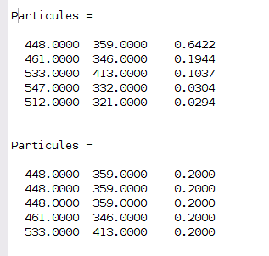
propagation :
here the propagation will give the particules new values ; trwing to get them to go a little bit everywhere and it happens before resampling so that it after resampling we can get only the values that are deemed relevant

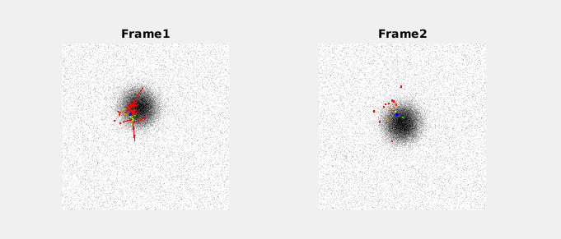
the weighting is done through the estimation of hom close a point is to the wanted goal, the more it is close to the gt the higher its weight is going to be,
when the particules are generated using the propagation, thew all have the same weight
and hen we will calculate their weight based on xxxxxxxxx

as show in the figure down below/
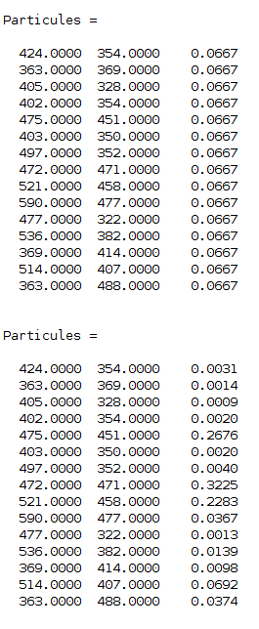
2 – the dynamic used impacts the quality of the propagation, if we use no dynamic, meaning everything is done randomly we tnd to have very bad results, however if we use the constant speed or constant acceleration, we have a particules population that is generated according to an underlaying logic,
3-
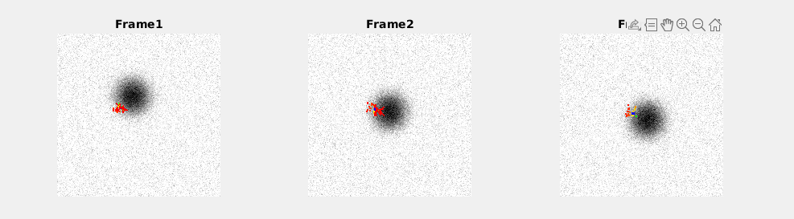
a higher sima means a propagation that is more relainat on the random, if we have too little random factor, it will impact our algorithm badly , and the same happens when it is too hig,
ze need to chose a sigma value that is balanced , meaning it should give us more random positions but also donest not lead to ignoring the dynamic

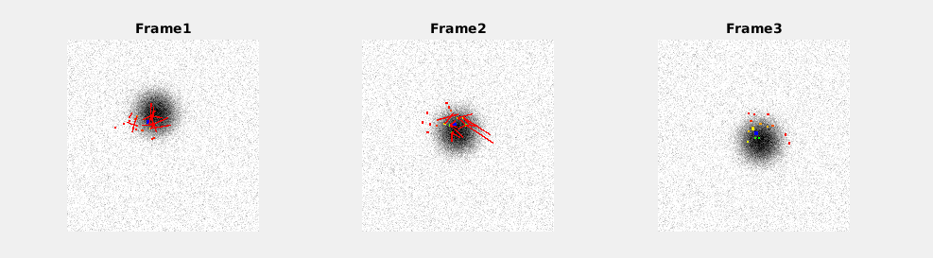
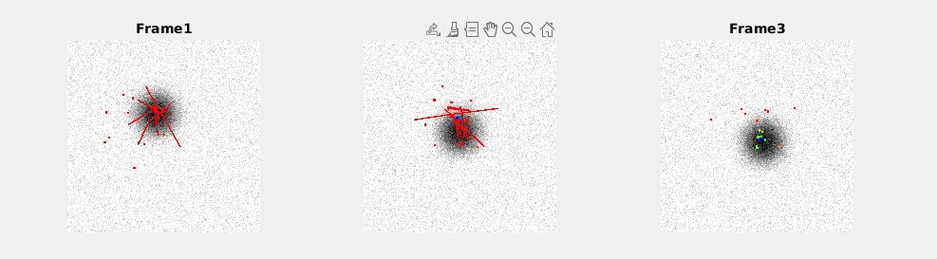
4-

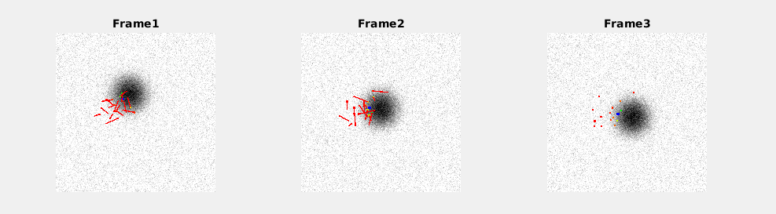
if we ommit the sampling, we ignore the weights each particule has, meaning that the particules that have a low weight, that are far from the wanted position are still present within the our population and so we have a slower convergeance rate towards the wanted output
5-

